33) Aim: To Design Turing Machine using simulator to accept all palindrome strings of all length over the set {a,b}.

Diagram:

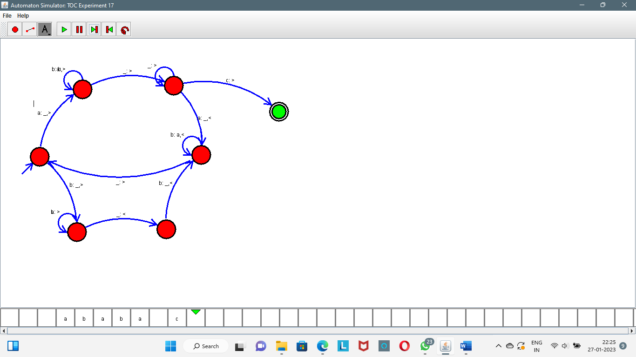

Result:

Successfully executed Turing Machine using simulator to accept all palindrome strings of all length over the set {a,b}.